# Project Costing

Below are the projected costs for Sudden Pine creating and implementing a system to monitor energy consumption in a solar powered home.

## Staff Costs

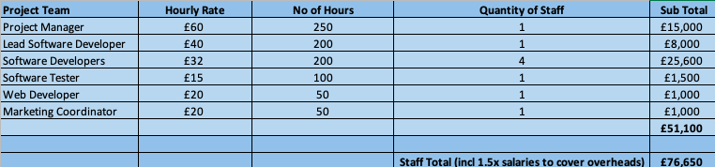

The staff involved in the project will consist of a project manager, a lead software developer who will oversee a smaller team of software developers, software testers, a web developer and a marketing coordinator. At certain points throughout the project, team members may take on the roles of more than one team member. For example the software developers will take on software testing on parts of the system they did not design.

The inclusion of overheads is necessary as the company will be required to pay national insurance, rent of office space etc in order for the team to undertake this project.

The hourly rate and number of hours of each team member has been calculated using yearly salaries and is based off an eight hour working day. Any potential oversights in there projected costs will be covered by the reserve funds.

## Hardware Costs

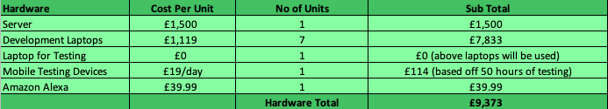

To complete this project to the highest standard, a mid-range server will be purchased. High-end laptops for the development team (software developers, web developer) will also need to be purchased to ensure that all team members have access to laptops that will perform to a high standard to complete the project. To keep testing costs down the development laptops will be used to ensure the web application works. Samsung mobile devices will be hired for 50 hours (6 working days) to allow for complete testing to be carried out.

As a potential requirement is enabling the system to connect to an Amazon Alexa, one may need to be purchased to allow for testing to be completed on this section.

## Software Costs

All software used to develop the system will be open source. Adobe XD will be used to ensure that mock-ups meet the clients expectations before creation of the system begins.

Software maintenance has not been included in this section of the project costing as it will be included in the reserves of the project. The client will receive any technical help from the project team for 30 weeks after the system is launched free of charge.



## Observation Trip Costs

To better understand the problem world that the team will be creating a system for, an observation trip to the solar village in Dubai has been included in the costing. The solar village features eco-friendly houses that have solar panelled roofs and are fully self-sustaining. The first phase of this village which has been open for four years, houses 500 villas and 89 apartments. An observational trip of these buildings would greatly improve the teams understanding of what they must create.

Flights are based off of return business class flights to Dubai. Extra company costs may include events such as the team taking the solar village developers for dinner to carry out research.

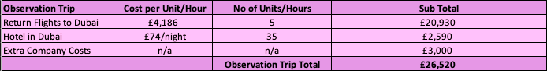

## Training Costs

One member of the software development team will be sent to work alongside the clients technical team for 40 hours to train them on the new system. Travel costs both to and from the clients headquarters must be subsidised for the team member.

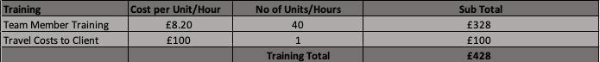

## Final Costs

The total of the project is displayed below. The team will require 20% reserves on top of the total project costs to account for any potential oversights or changes made to the project.

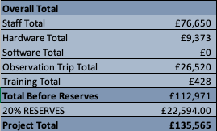

## Costing References

* Project Manager Wage -<https://www.payscale.com/research/UK/Certification=Project_Management_Professional_(PMP)/Hourly_Rate>
* Other Staff Wages - <https://www.glassdoor.co.uk/Salaries/>
* Server Costs - <https://www.manxtechgroup.com/how-much-will-a-server-cost-uk/>
* Laptop Costs – Based on HP Spectre X360
* Amazon Alexa - <https://www.amazon.com/Amazon-Echo-And-Alexa-Devices/b?ie=UTF8&node=9818047011>
* Flights to Dubai – Based on Business Class flights with Emirates
* Solar Village - <https://www.businessinsider.com/dubai-sustainable-city-uae-2018-1?r=US&IR=T#the-113-acre-city-aims-to-curb-co2-emissions-as-much-as-possible-cars-are-banned-from-most-neighborhoods-2>